Press Release: Review

Process Insights Germany 2019 in Nuremberg
Over 140 participants at Method Park Process Management Conference
Many representatives from regulated industries participated in Process Insights Germany on March 12 in Nuremberg. With this conference, Method Park responds to the increasing complexity of engineering processes and the demand for a platform to exchange know-how and experience.
Erlangen, March 21, 2019 – Last Tuesday, over 140 participants joined Process Insights Germany 2019, the conference to which the consulting company Method Park invites participants every year. The participant numbers increased by more than 50% compared to the prior year – a record high in the 13 year conference history. For the first time, international guests participated in the conference and Method Park engaged a simultaneous interpreter for them. Companies from the automotive industry, medical technology, aerospace and IT sent their process experts to Nuremberg.

Central Topic: Process Management
Keynotes, presentations, discussions, round tables, a specialized exhibition and the Consulting Café focused on the challenges of product manufacturers worldwide: efficient management of business or engineering processes, compliance to standards and norms, and the integration of tools. The demand for the exchange of know-how and experience in these topics is at an all-time high. Today, the development of technological products has reached a level of complexity which is only controllable with efficient processes. Technical presentations highlighted individual factors of process management and their solutions. With best practices, user presentations demonstrated how tools such as Stages, developed by Method Park, contribute to simplify processes. In round table discussions, the participants deepened individual aspects of the presentations. The final keynote showed that, in addition to all technical and structural changes, the company culture has to be sustainably formed for the future, too.

20 Sessions in the Consulting Café
In parallel to the round tables, Method Park organized a Consulting Café, as in previous years. These consulting services were offered free of charge and with 20 sessions in all, Method Park Consultants were fully booked. The most frequently requested topics were methodical approaches of process management and the practical use of Stages.
“Supported by the dedicated work of our program committee, consisting of representatives from Audi, Hella, Schaeffler and ZF, we developed a very extensive and demanding program this year. It was worth the effort – the participant feedback was excellent. It also reflects the rapidly growing relevance of processes in the development of complex products,” says Dr. Erich Meier, Method Park CTO, about the success of Process Insights Germany 2019.

Outlook 2020
Backed by this positive feedback, the planning for Process Insights Germany 2020 has already started. On March 11, 2020, Method Park will again offer a platform for discussions around the management of engineering processes. The call for papers will start soon.
Number of characters (space characters included): 3.086
About Method Park
Method Park specializes in complex product engineering for the automotive, medical, and aerospace industries. Method Park’s portfolio includes consulting and engineering services, a comprehensive training program and the process management tool “Stages”.
Method Park was founded in 2001. On a worldwide basis, the company has supported and coached its customers on process optimization, compliance to industry-specific standards and legal regulations, as well as the management of projects, products and quality assurance. Method Park offers a practice-based training program on all current topics of Software & Systems Engineering. In 2017, Method Park became official VDA QMC training provider of Automotive SPICE® courses. For the recent version of Automotive SPICE® V3.1, Method Park has developed a free app for iOS and Android.
With “Stages”, Method Park offers a model-based process management tool, which supports its users on the definition, communication and application of complex processes, particularly in the engineering environment – globally, beyond organizational borders and always in compliance with various industry-specific standards.
The company group has locations in Erlangen, Frankfurt on the Main, Hamburg, Munich and Stuttgart as well as in Detroit, Miami and Pittsburgh in the US. Today, about 200 employees work for Method Park. In 2018, Method Park generated an operative turnover of about 19 million euros.
For further information please contact:
Bernd Langer, Business Development
Method Park Software AG, Wetterkreuz 19a, 91058 Erlangen, Germany
Bernd.Langer@methodpark.de www.methodpark.com
Available pictures:
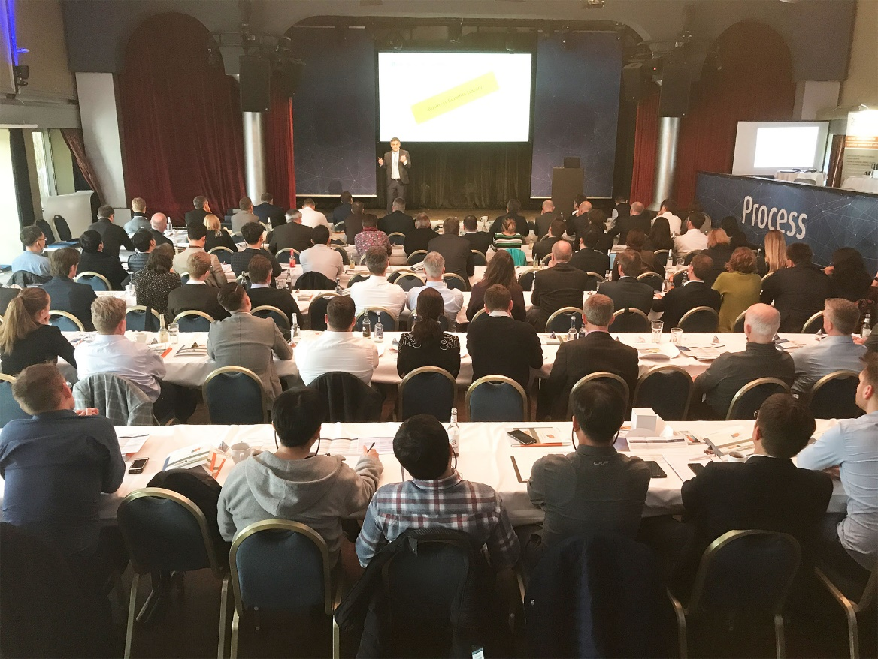
Caption: Method Park CTO Dr. Erich Meier presents the Stages Roadmap at Process Insights Germany 2019.
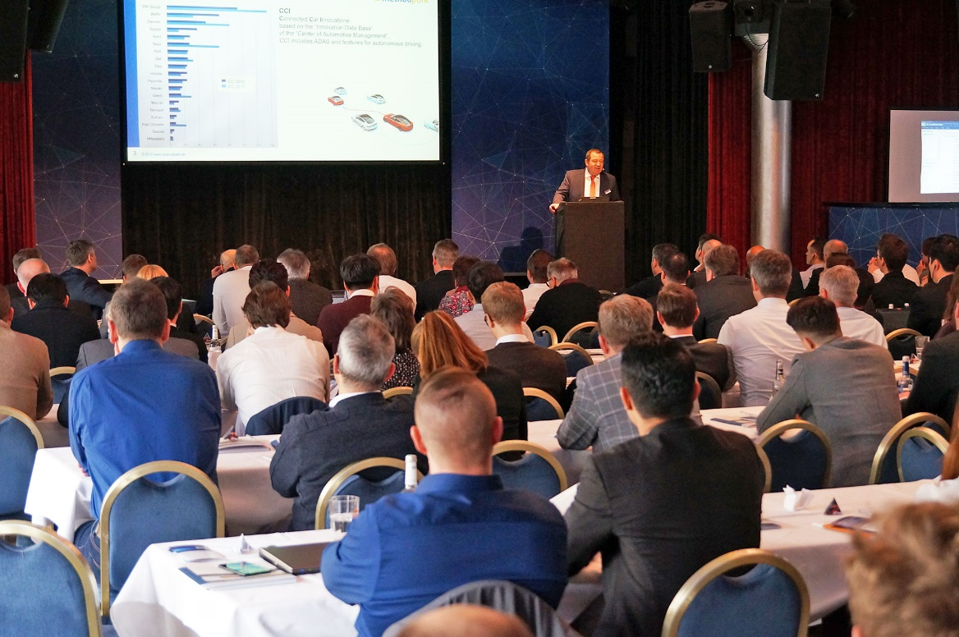
Caption: Prof. Dr. Bernd Hindel, Method Park CEO, outlines compliance to the industry standard Automotive SPCIE®.

